A short tutorial on using the Orange Data Mining Suite
Orange is full-fledged data mining suite offering methods in all areas of data mining. It is written in the Python programming language and has two main interfaces: (1) through modules written in Python that can be called as libraries if you are interested in building new data mining algorithms, while using existing algorithms already implemented in Orange (2) a visual programming interface where you use Widgets on an Orange canvas to generate models for specific data mining applications. For example, to build a decision tree for Iris you can use the Visual Programming interface by building a schema consisting of modules such as the File module, Classification Tree module, Test Learners module, and so on as illustrated in the schema below.
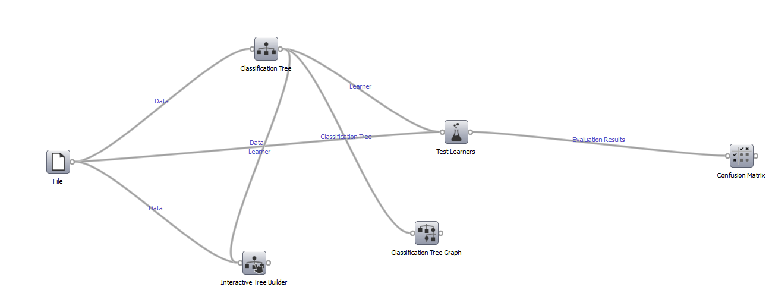
Simply drag and drop widgets from the palette onto the canvas. The File icon, as its name suggests is to input data. Orange comes with a number of in-built datasets and by default these datasets are located in c:\Python27\Lib\site-package\Orange\datasets folder. Note if you use Orange on your home computer the folder in which Orange loads its datasets may be different.
To load the data, simply activate the File widget by double clicking on it and providing the file pathname.
Now drag and drag and drop the other widgets on the canvas as shown in the figure above. Establish links between the widgets as shown in the figure above.
Now we are in a position to build and evaluate a model for the Iris dataset. We will build a model interactively, meaning that we will develop the decision tree in stages (not all at once). We will first specify a depth of 2 for the tree, evaluate its accuracy, then increase tree depth to 4, evaluate, and so until we stop when we have reached a point where accuracy cannot be increase any more. In order to build the model in this step-wise interactive fashion we need both the Classification Tree widget as well as the Interactive Tree widget. To control the growth of the tree we activate (double-click) the Classification Tree widget and specify parameters as given below:
Index  Classification Tree | Classification TreeThu Mar 14 13, 14:26:06  Learning parameters  Attribute selection: Information Gain  Binarization: No binarization  Pruning: 2 instances in leaves, 3 instance in node, maximum depth 2  Recursively merge leaves with same majority class: Yes  Pruning with m-estimate: m=2  Data  Examples: 150  Attributes: 4 (sepal length, sepal width, petal length, petal width)  Class: iris
(Note: depth has been set to 2). Now activate the Interactive Tree widget. Navigate to the ‘Build” tab and click the “build” bar. The resulting tree with depth 2 will be displayed in the right hand pane in a textual fashion. While this is useful, even more useful would be an actual graphical representation. To generate this, use the Classification Graph widget. Simply activate this widget and a graphical version of the tree will be produced as shown below. There is save graph option which saves the image in .png format.
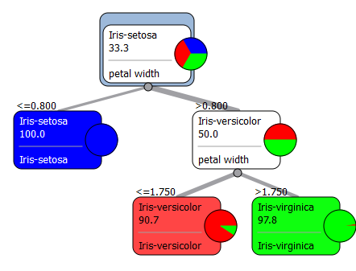
Now to the last step of model evaluation. To do so we first activate the Test Learners widget. Use the parameter options given below:

Results
 | CA
Classification Tree | 0.9216

Test LearnersThu Mar 14 13, 14:42:02

Validation method
Method: Random sampling
Repetitions: 5
Proportion of training instances: 66%
Target class: Iris-setosa

Data
Examples: 150
Attributes: 4 (sepal length, sepal width, petal length, petal width)
Class: iris

Results
 | CA
Classification Tree | 0.9216
(Note we are using the test on testing dataset option and using random sampling as the testing method. Select Classification Accuracy as the performance scores tab. Note that the overall classification accuracy (CA) of the Iris model with tree depth 2 is 92.16%.
In order to get a more detailed evaluation report we use the Confusion Matrix widget. Activate this widget and the confusion matrix will be printed out as given below:

Confusion MatrixThu Mar 14 13, 14:48:47

Contents
Learner: Classification Tree
Data: Number of examples

Matrix
 | Iris-setosa | Iris-versicolor | Iris-virginica
Iris-setosa | 85 | 0 | 0 | 85
Iris-versicolor | 0 | 78 | 7 | 85
Iris-virginica | 0 | 13 | 72 | 85
 | 85 | 91 | 79 | 255
Note: columns represent predictions, row represent true classes

Now repeat the entire process with tree depth =3, 4 and 5 and observe the corresponding changes in the tree and the confusion matrix.

Once this is completed, I suggest that you add the Nearest Neighbor and Naïve Bayes algorithm (through their respective widgets) so that you can compare accuracies across different algorithms.

